Project 2002-07-000

Restoring Anadromous Fish Habitat in the Lapwai Creek Watershed

Sponsor: Nez Perce Soil & Water Conservation District (SWCD)

Response to ISRP Review

The NPSWCD collaborated with the Nez Perce Tribe (NPT) to complete our responses. For this reason, many of the responses and summarized information is the same. We have included the NPT proposal # 199901700 response as an attachment to the web site. In order to reduce redundancy we have summarized the information needed in this document. Our proposal has a reduced budget due to local budgeting revisions.

ISRP Comment #1
1. Between this and its sister NPT project, many thousands of dollars have been spent over the past four years, and there is no end in sight. Project accomplishments are so minimal, by any standards, and there are so few riparian or instream benefits evident, that the project should not be continued without a thorough programmatic review.

Response
Unfortunately our original proposal did not clearly reflect the amount of work we have accomplished. The NPSWCD revised section F of the narrative to clearly reflect project accomplishments to date. This project was originally funded by BPA the fall of 2002 and has completed 3 calendar years of project work.

Prior to the initiation of this project, a massive data gap existed on fish, the condition of fish habitat, and limiting factors within the watershed. Only a minimal amount of baseline data collection had occurred. To fill the data gaps, the NPSWCD collaborated with the NPT to collect the needed information. The NPT was the lead in collecting information except for habitat condition, existing riparian vegetation, and stream temperature. All of these are being collected by the NPSWCD.

Because the existing PL566 watershed plan, Clearwater subbasin Management Plan, and Lapwai Creek watershed assessment identified some priority treatment needs, the NPSWCD completed habitat restoration activities within the watershed (these are outlined below).
Implementation activities began in 2003. The specific accomplishments during the 3 years are shown in Figure 1 and Table 1. Accomplishments are shown in the BPA metrics format. Please see the NPT response as it shows this table with both the NPT and NPSWCD accomplishments listed.

Table 1. Accomplishments by metric.
Metric | 2003 | 2004 | 2005 | 2006  Status from 3/1/06 to 7/14/06 | Total
BPA Metrics
# of fence miles in Riparian area |  | 1.1 | 3.03 | 0.19 | 4.32
# of fence miles in Upland area | 0.27 | 5.03 | 0.92 | 1 | 6.21
# of road miles in Riparian area |  | 1.1 | 3.03 | 0.19 | 4.32
# of road miles in Upland area | 0.27 | 5.03 | 0.92 | 1 | 6.21
# of Stream Miles treated |  | 0.94 | 0.44 | 0.15 | 1.53
# of structures installed |  | 6 | 2 | 1 | 9
Wetland Acres Treated |  | 0.55 | 4 |  | 4.55
Riparian Miles Treated | 1 | 3.74 | 3.08 | 0.3 | 8.12
Upland Acres Treated | 4382.7 | 7146.6 | 3448.7 | 231 | 15,209
Riparian Acres Treated | 19.5 | 183 | 115 | 73.3 | 390.8
Miles of habitat accessed to the next upstream barrier |  |  | 16 |  | 16
Other Metrics
Miles of stream habitat inventory completed (SVAP) | 40 | 80 | 93 | 40 | 233
Number of individual projects installed | 20 | 50 | 50 | 6 | 126
Conservation Practice Units Completed
Livestock Waste Systems | 3 | 5 | 2 | 0 | 10
Alternative Water Developments | 0 | 16 | 5 | 0 | 21
Direct Seed and no-till systems applied (acres) | 4367.7 | 5877.7 | 2237.7 |  | 12483.1
Weed control to maintain vegetation planted in riparian and wetland areas (acres) |  |  | 130 | 7.6 | 137.6
Weed control to establish vegetation (acres) |  | 736 | 42 | 36.2 | 814.2

FIGURE 1: Completed Project Sites

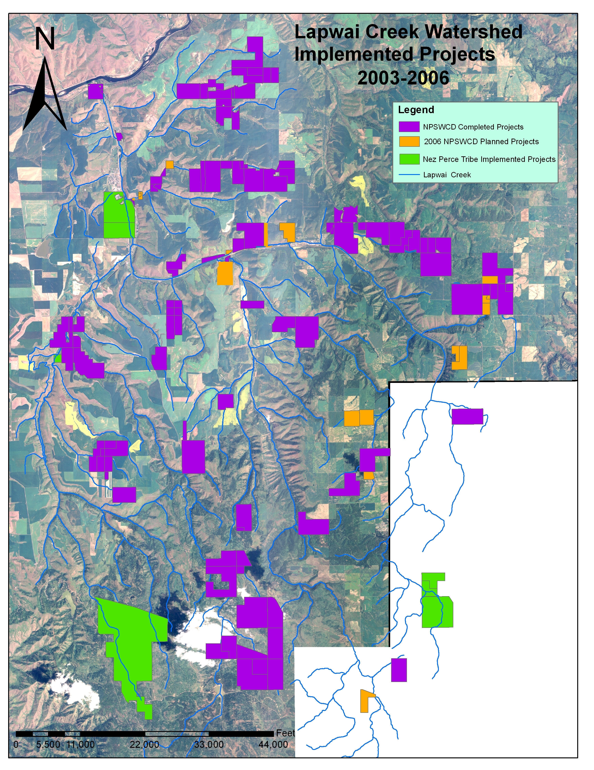

Project work examples:
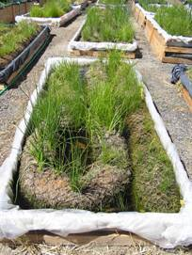

Through the SVAP inventory, NPSWCD staff identified numerous bank erosion sites requiring treatment. The staff decided to treat these areas with wetland sod and biologs (shown left). Biologs consist of 8 to 24 inch coir fiber rolls in 20 foot lengths. The rolls are planted with sedges and rushes and then placed at the toe of eroding banks to establish vegetated protection.

The biolog materials were not readily available, so the NPSWCD staff grow the materials in tanks outside the office. Wetland plants are obtained from local sites in the watershed, divided into plugs, and planted in the coir rolls. The biologs are planted in May and grown through October. They are then planted in the dormant season from November through March (depending on elevation).

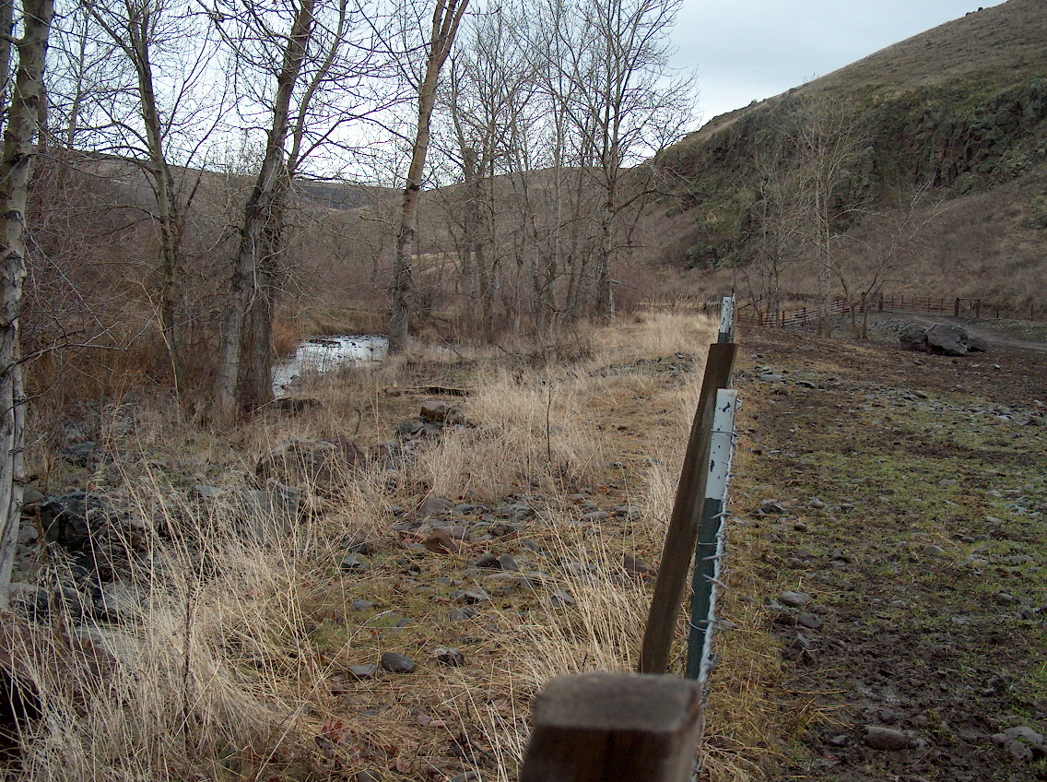
Example of a fence installed to exclude livestock from stream. This area is used to feed 150 head of cattle from October through April each year. Prior to the fence installation, livestock had uncontrolled access to the stream.
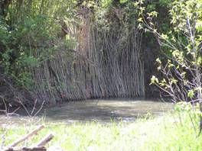
Example of a brush mattress installed to reduce streambank erosion. The brush mattress contains native willows and serves to protect the bank from erosion, while vegetation is established. Prior to project work, seining was completed and steelhead juveniles were found.

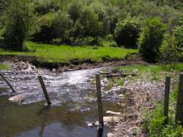
Example of a tree revetment installed along Mission Creek to reduce streambank erosion. The tree revetment consists of 12 inch diameter pine trees with limbs, cabled together and anchored to the bank toe with duckbill earth anchors. Willows are planted behind the revetment. The willows will provide long-term bank stability.

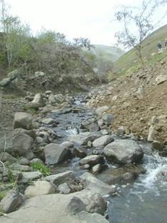
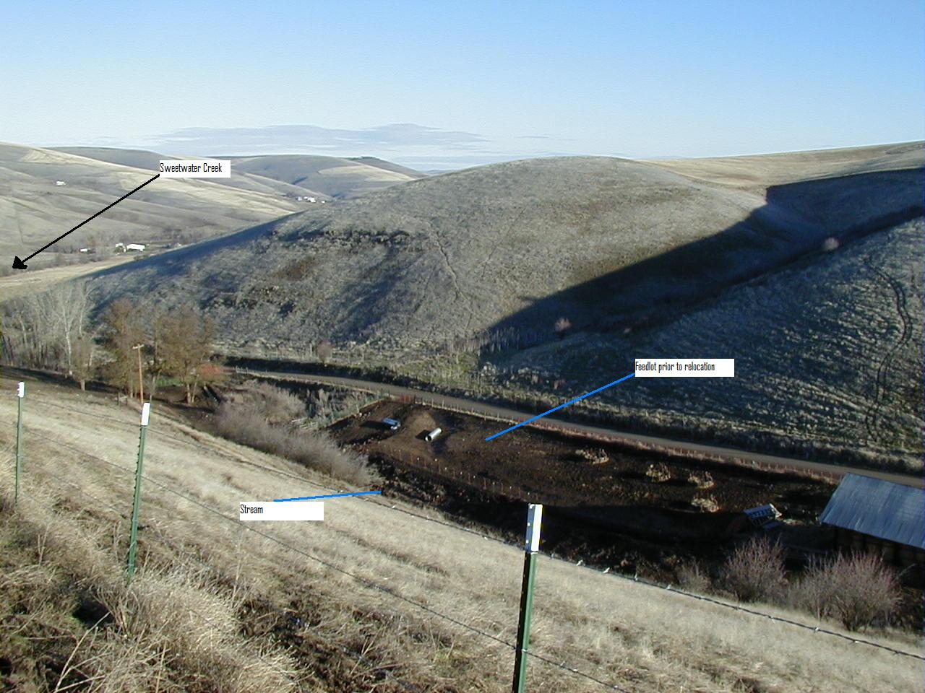
Upper Photo shows a livestock feedlot directly located on a tributary to Sweetwater Creek. The photo to the right illustrates the stream channel at this location. Livestock were confined along the stream channel throughout the year. The lower photo shows the feedlot relocated to a ridgetop site where cattle are excluded from the stream. This stream is a tributary to Sweetwater Creek and is used for steelhead rearing. This photo shows the project site prior to installation of habitat improvement measures. The site is a feedlot for 200 head of cattle. Prior to project work, livestock obtained water from the stream. Habitat improvement measures installed at this site include a livestock waste management system (described below), fence, grass seeding, tree plantings, alternative water system and road improvement.

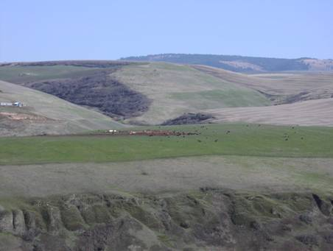

Our original goals in 2002 were:
- Collect additional inventory, assessment, and monitoring data identified in the 2001 Aquatic Assessment.
- Remove livestock feeding operations from access to the stream. Operations were identified by EPA as having significant water quality impacts. 10 operations were identified for removal.
- Complete the installation of fish habitat projects identified through the PL566 watershed program. 12 projects were identified.
We have completed goal 2 and will complete goal 3 the fall of 2006. Goal 1 will be completed the fall of 2007. Our planning team met the winter of 2005 and identified the following priority areas for restoration efforts (based on preliminary data provided from goal 1): Mainstem Lapwai Creek, Rock Creek, Garden Gulch Creek and Mission Creek. We are using this preliminary prioritization to identify projects and produce designs for project installation in 2007.
The majority of the identified data gaps will be completed by the NPT proposal #199901700. However, the NPSWCD collected data for habitat condition inventory and stream temperature monitoring. This baseline data will include information from various agencies within the watershed. Some of the major products from each agency are included below:

NPSWCD
- By fall 2007, the main stem and all major tributaries of Lapwai Creek will have been assessed using the Stream Visual Assessment Protocol (SVAP). SVAP is a rapid assessment of stream/riparian/landscape condition that allows qualitative comparison between reaches. This process allows the identification of treatment strategies to improve steelhead habitat. The assessment also identifies site-specific problems and treatment needs. For example, in-stream irrigation diversions, dikes, streambank erosion sites, canopy cover needs, weed densities (which helps refine the strategy needed to improve and/or enhance the riparian areas). Figure 2 shows the status of SVAP completion.
- A riparian canopy assessment through the use of digital orthophotos has been completed. This assessment delineates reaches of poor (bare ground), fair (< 15m), or good (>15m) riparian buffer widths. This assessment will help focus riparian restoration efforts (see figure 3).
- Stream temperature monitoring is completed at the major tributaries of Lapwai Creek. This monitoring will provide base-line data showing the location of stream temperature problems. Data from 2003 to 2006 will be analyzed and a report completed in January 2007.
NPT Watershed
  - Fish distribution and abundance data as well as habitat data has been collected since 2002. 2006 is the final year of data collection, and all reports are expected to be completed by fall 2007.
  - A fish passage assessment was produced in 2003, which assessed all road/stream crossings in the watershed using a modified USFS protocol.
NPT Water Resources
- A TMDL assessment will be completed by Dec. 2006. This effort has included several years of water quality data collection at strategic points within the watershed, development of thermal infrared imagery, and a complete LiDAR survey of the watershed.

We will use the findings from this information to refine our current priorities and identify specific treatment areas. Our planning team met the winter of 2005 and identified the following priority areas for restoration efforts (based on preliminary data provided from goal 1): Main stem Lapwai Creek, Rock Creek, Garden Gulch Creek and Mission Creek. We are using this preliminary prioritization to identify projects and produce designs for project installation in 2007.

Figure 2. SVAP status map. 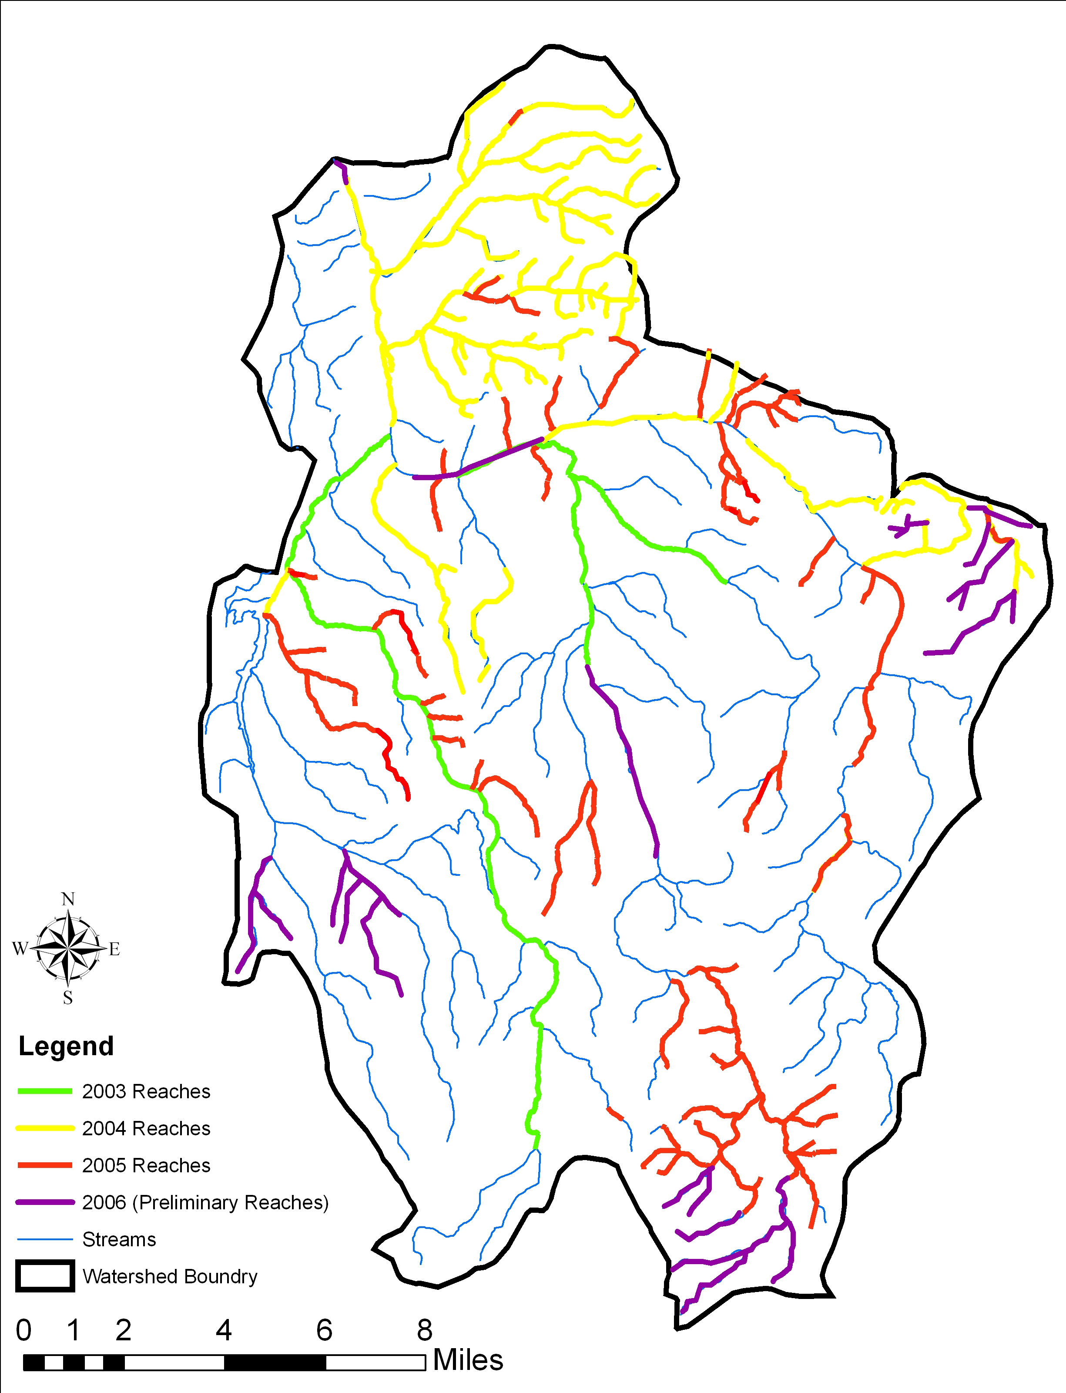

Figure 3. Multi-layer riparian canopy inventory.
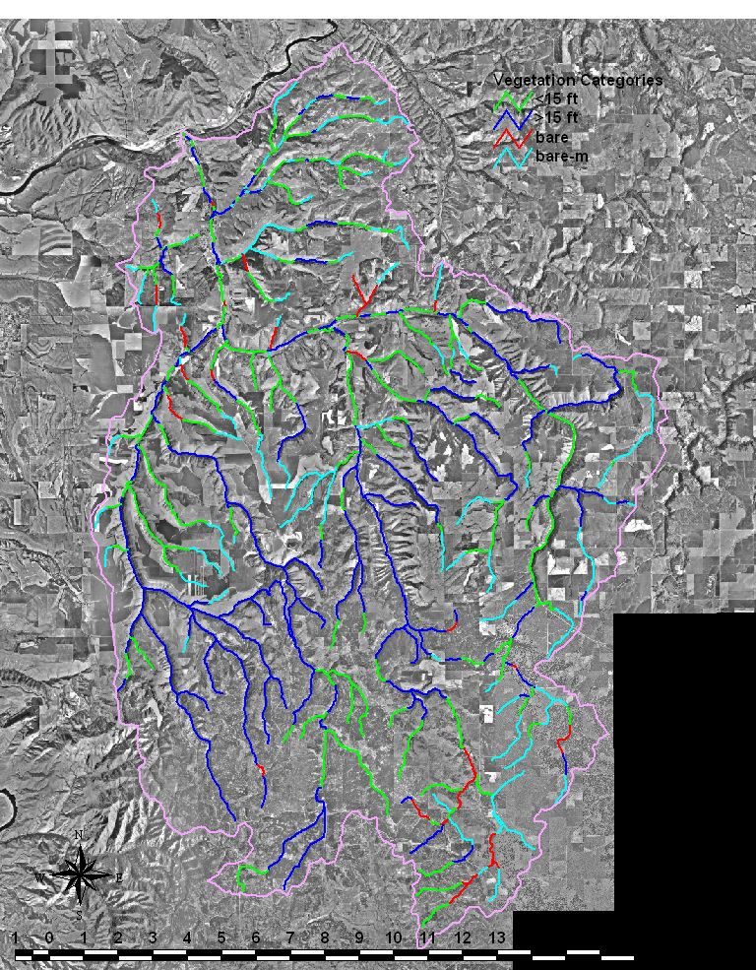

- Remove critical livestock feeding operations from access to the stream. Ten operations were identified by EPA as having significant water quality impacts.
In realizing that this data collection phase would involve a substantial amount of manpower and take several years to complete, the NPSWCD began implementing watershed rehabilitation activities concurrently with the data gathering activities. Based on a livestock feeding operation inventory completed in 1998 and the Lapwai Creek PL566 watershed plan which identified livestock operations as a priority treatment unit, the NPSWCD chose 10 priority sites. To date, all 10 sites have been completed and livestock access removed from the streams.
The sites were located on major tributaries within the watershed; Tom Beall (3 sites), main stem Lapwai Creek (3 sites), Webb Creek (2 sites), Mission Creek (1 site), and Sweetwater Creek (1 site).
- Complete the installation of fish habitat projects identified through the PL566 watershed program. 12 projects were identified.
Twelve fish habitat restoration projects had been identified and landowner agreements obtained. PL566 funds were allocated to the projects; however, a lack of technical assistance and project installation costs prohibited the installation of these projects. The NPSWCD installed all 12 projects using BPA funds to finalize designs, complete construction layout, hire contractors, and provide landowner assistance.
- Improve anadromous and resident cold-water fish habitat through riparian area enhancement and sediment reduction.
Based on the PL566 watershed plan, 170,605 tons sediment were identified were identified as needing reduced. Table 5 shows the progress in meeting this goal.
- Reduce stream temperatures through riparian enhancement (lower the maximum mid-summer water temperature by 5 degree centrigrade).
Based on the PL566 watershed plan, 53 miles of riparian habitat were identified as needing treatment. Table 5 shows the progress in meeting this goal.
- Enhance degraded hydrologic conditions and decrease sediment yield in the upper watershed through runoff retention and detention practices.
Based on the PL566 watershed plan, 409 roads and 170,605 tons of sediment were identified as needing reduced. Table 1 shows the progress in meeting this goal.
The NPSWCD expects tremendous riparian benefits from the work completed to date. Over 8 miles of riparian restoration was completed during this project phase. Expected results over the next ten years are illustrated the following photographs. This figure shows a project site on Hatwai Creek (located within the Lower Clearwater, approximately 8 miles from Lapwai Creek) which was restored in 1992. Note the change in riparian condition from 1992 to 2006. We expect to achieve similar results as the Hatwai site has similar soils, land uses, and climate.

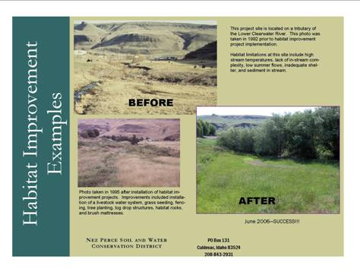

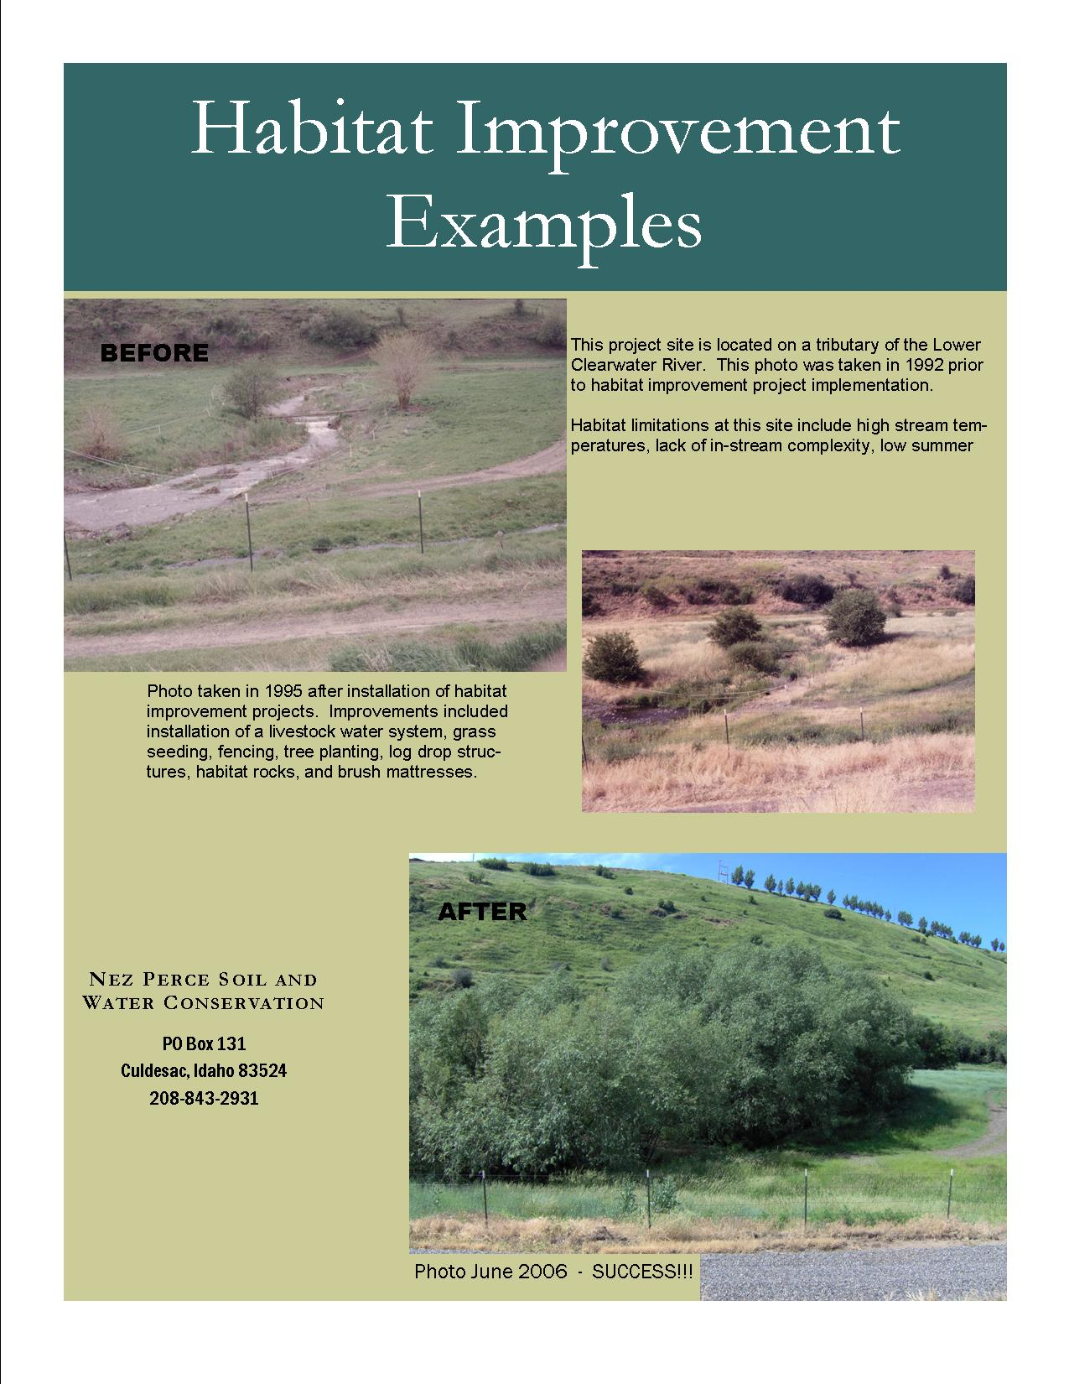

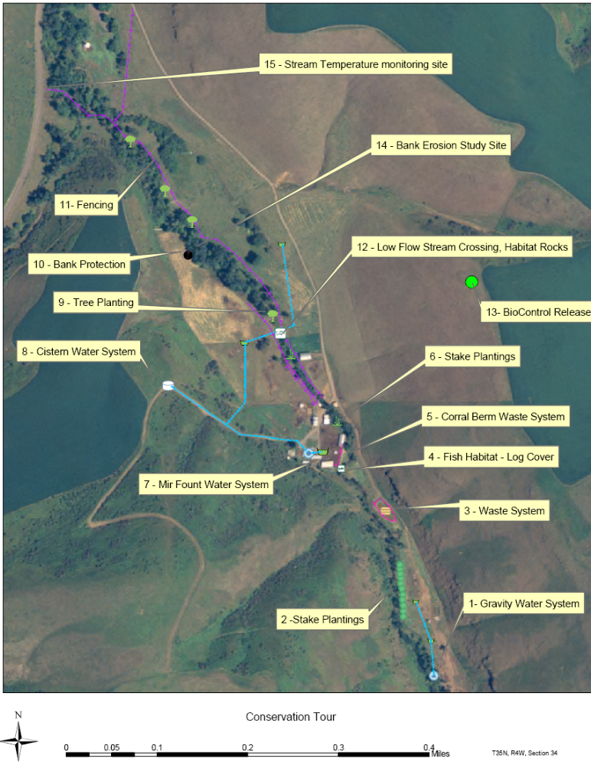
Conservation plans as illustrated above include several components. The plan shown above illustrates the amount of project work needed for restoration at a single site on Webb Creek.
- Gravity Water System.
This system was installed in the summer of 2003. Water is collected through perforated pipe, stored in a concrete storage box and then piped to two rubber tired troughs. The system is a flow-through system. This means that water enters the system from the upstream collection and exits the system through an outlet installed downstream of the last trough. The project was funded through the PL566, BPA programs and landowner contributions. Estimated costs are $4,000.
- Stake Plantings
The stake plantings were installed in November 2004. These plantings consist of dogwood, coyote willow and pacific willow. The plantings were installed with an excavator and locally collected dormant stakes. They were installed approximately 8 feet deep. The project was funded through the PL566, BPA programs and landowner contributions. Estimated costs are $600.
- Waste System.
The waste system was installed in 2003 and consists of a waste storage pond, grading and shaping, fencing, and grass seeding. The project was funded through the PL566, BPA and landowner contributions. Estimated project costs are $17,000.
- Fish Habitat – Log Cover.
The log cover will be installed in July 2005. The project will be funded through EQIP, BPA and landowner contributions. Estimated costs are $500.
- Corral Berm Waste System.
This system was installed in 2003 and consists of a corral berm, corral fencing, roof runoff system and lot shaping. The system was funded through EQIP, BPA, and landowner contributions. Estimated costs are $6,000.
- Stake Plantings.
The plantings were installed in 2001 by hand planting dormant coyote willow stakes at the toe edge. The project was funded through the EQIP and landowner contributions. Estimated costs are $500.
- Mir Fount Water System.
The Mir Fount water system was installed in 2003. This system consists of pipeline, trough, and concrete pad. The system was funded through BPA and landowner contributions. Estimated costs are $1,800.
- Cistern Water System.
The project consists of a cistern, pipeline and two troughs. The water is supplied from an existing well near the house and pumped to the cistern. Water is delivered to the troughs by gravity. The project was funded by landowner contributions, BPA and PL566. The system was installed in 2004 . The pipeline that crosses the stream will be installed in 2005.
- Tree Planting.
Trees and shrubs were planted along the riparian area in February 2005. The trees were container stock and are protected with yellow protectors. Funds for this project were from the BPA program. Estimated costs are $2,000.
- Bank Protection.
This project consists of tree revetment and brush mattress. The project will be installed in 2005. Funding for this project is EQIP, BPA, and landowner contributions.
- Fencing.
Fence was installed in December 2004. Funds for this project is from landowner contributions, Nez Perce Tribe BPA project and the Conservation District BPA project.
- Low Flow Stream Crossing, Habitat Rocks.
A low flow stream crossing and habitat rocks will be installed in July 2005. Funding for this project is from landowner contributions, EQIP, and BPA.
- BioControl Releases.
BioControl agents for yellow starthistle were released the summer of 2004. Funding for this project is from the BPA project and Americorps Labor. Estimated costs are $400.
- Bank Erosion Study.
This site is part of a watershed wide erosion study to determine streambank erosion rates.
- Stream Temperature monitoring.
Stream Temperatures are collected at 12 sites within the watershed. This site monitors the temperature of Webb Creek.

ISRP Comment #2
2. The response requested is to include development of a revised proposal that addresses the problems identified in the current version (identified here and additionally, review comments for project #199901700). The new proposal should be required before funding or deciding whether to fund in part or full is appropriate. The revised proposal should be fewer than 25 pages.
The new proposal needs to be carefully written including an Abstract that accurately reflects the objectives and progress to date. The background should be clearly presented and show a clear basis in science. Factors known to be limiting population distribution and abundance need to be clearly identified with strategies for overcoming their impact. The strategy needs to include prioritization from within a subbasin plan or documented watershed analysis/assessment/prescription. The information presented needs to be summarized and simplified into a package that simply relates the objectives and tasks outlined in the subbasin plan. There has to be clear ties defined with project #199901700.

Response

Please see revised proposal as well as attached response to comments for project #199901700.

ISRP Comment #3
3. Monitoring plans need to be included to show implementation success and biological response following a carefully planned experimental design. Proposal development requires a rigorous involvement of personnel trained in biological science, proposal and report writing, and watershed ecology.

Response
Compliance and effectiveness monitoring is the process we will use to determine if the habitat improvement practices installed are functioning as designed, are being maintained, and are improving habitat. Specific monitoring to determine a biological response of A-run steelhead is included in the proposal of our sister project through the NPT Watershed.
The NPSWCD and NPT employ professional staff; in order to best utilize the pool of combined knowledge and skills, efforts were coordinated while preparing this proposal. These additional players are integral to the success and coordination of implementation projects in the Lapwai Creek watershed as well. Please refer to Section H of the revised proposal to review professional credentials of staff.

